|  |  |  |
| --- | --- | --- |
| *[Formatting guidelines for abstract submission]*  Title |  | EARSeL Lisbon 2026  Abstract  Corresponding Author: [[email-address]](mailto:liege2021@earsel.org) |

Roy Orbison1, Second Author2, Third Author3, Fourth Author4   
*(Style: Authors, presenting author underlined)*

1 University of xxx, Department of xxx, Belgium   
2 University of XXXXXX, Country  
3 University of XXXXXX, Country  
4 University of XXXXXX, Country  
*(Style: Affiliations;)*

**Keywords (5):** Earth Observation, Urban, Hyperspectral, Land Use, Copernicus

Challenge

This document serves as a formatting template for authors submitting an abstract to the **14th EARSeL SIG WS Forest Fires 2026**. It contains all the necessary style elements for you to prepare the abstract in the preferred format. This abstract will be used to assist the organizers in selecting papers for presentation and posters and in designing the programme. The abstract should contain four sections: The challenge, methodology, study area and data, and discussions and conclusions. The abstract should contain between **4000 (min) - 5000 (max) characters** and does not normally contain references. 1-2 figures shall be provided at the end of the text. As in the example below, the figure should be centred and occupying the whole space without any text on the right and left-hand sides. Graphics should have an adequate resolution (min 300 dpi.). The document itself is set out using the layout and styles for the abstract. Your abstract should be saved in a file named as follows: “**ID**_**Name of Author_EARSeL_FF_2026**”. Your ID can be found in your user account details in ConfTool. The document is required to be uploaded in ConfTool in docx or pdf format to be considered for review.

**Methodology**

*Fill in content.*

**Study area and data**

*Fill in content*

**Discussion and Conclusions**

*Fill in content.*

*Please upload 1-2 figures or graphical abstract (min 300 dpi. jpeg/png)*

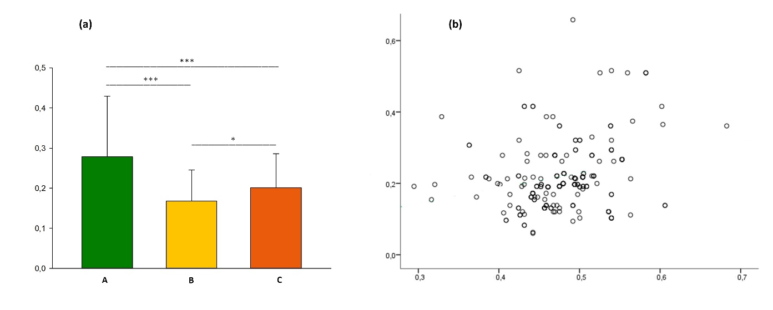

**Figure** (a) example of coloured figure and (b) example of grey-scale figure